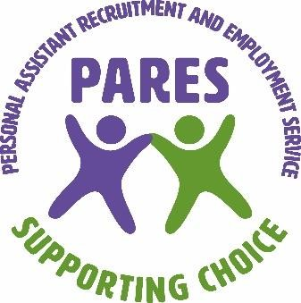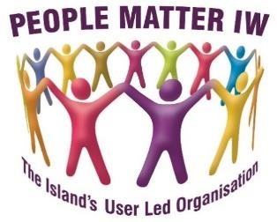

Personal Assistant and Recruitment Employment Service (PARES)

INFECTION CONTROL ANNUAL STATEMENT 2026

PURPOSE
This annual statement will be generated each year in January. It will summarise:
- Any infection transmission incidents and any action taken (these will have been reported in accordance with PARES Infection Prevention and Control Policy.)
- Details of any infection control audits undertaken, and any actions taken.
- Details of any infection control risk assessments undertaken.
- Details of staff training
- Any review and update of policies, procedures and guidelines

BACKGROUND
Terri Baker – Registered Manager and Lea Fairclough PARES Officer/ Nominated Person are responsible for ensuring PARES staff have the appropriate infection control training. They also share any information with the staff via supervision meetings or emails.

AUDITS
An Infection Control Audit was carried out on 01.02.2026 with the next advised for January 2027. This can be carried out at any time due to ongoing changes.
To ensure our clients are fully informed of our Infection Control audit outcomes, a copy of this annual statement will be placed on our website. We will also notify staff of any information they may need to be aware of when supporting our clients This will be communicated via information emails, telephone calls, texts and WhatsApp.

PARES Infection Control Summary
An infection control audit was undertaken on 01.02.2026. No actions were required as policies and risk assessments are regularly reviewed and updated to ensure the safety of staff and service users.
Infection Control Risk Assessments are undertaken as a part of the initial PARES Risk and Positive Outcomes Assessment.
All staff have mandatory online Infection Control training via Careskills Academy.
To ensure the health and safety of staff and service users, some staff have been asked not to work if they have come into contact with a person who has cold, cough or stomach infection. This is assessed on an individual basis especially if the client is assessed as being highly vulnerable.
PPE (Personal Protective Equipment) disposable masks, gloves, aprons, are readily available.
All staff have been encouraged to take up the Covid-19 boosters and seasonal flu vaccinations every year.
PARES is recording and reporting information to the relevant organisations including Local Authority and the national Capacity Tracker.
PARES Infection Prevention and Control Policy is in place with additional policies to support it:-
Hand Hygiene
Service User Placement Assessments
Personal Protective Equipment
Respiratory and Cough Hygiene
Safe Disposal of Waste
Safe Management of Blood and Body fluids
Safe Management of Care Equipment
Safe Management of Sharps and inoculation injuries
Safe Management of the Care Environment
Statement written by Lea Fairclough – PARES Officer/Nominated
Person Statement approved by Terri Baker – Registered Manager
Signed: LEA FAIRCLOUGH Dated: 01.02.2026
Signed: 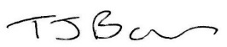 TERRI BAKER Dated: 01.02.2026

